SCOIR is a very intuitive program – getting started is easy.

This tutorial will take you through the registration process, updating personal information, signing up to receive notification from SCOIR, and the landing screen layout.

You will receive an invitation to register with SCOIR via email. I believe I am sender and the subject line will read, “Scott Invited you to SCOIR.” If you have not received this invitation within 24 hours of being informed that invitations were sent, please contact Mr. Chrysler. The invitation will expire. It is critical you activate your account promptly.

Once you receive your invitation, simply click on the Complete your registration button to begin. By clicking on this button, you will verify your email address with SCOIR and create your account. When you return to access SCOIR, you will need to go to www.scoir.com not the link in the initial invitation email.

NOTE: A unique email address is necessary for each SCOIR account. If two parents have the same email address in myESA, from which the data has been pulled to create parent SCOIR profiles, only one account will be created for both parents. If you would like an additional account, please contact the college counseling office.

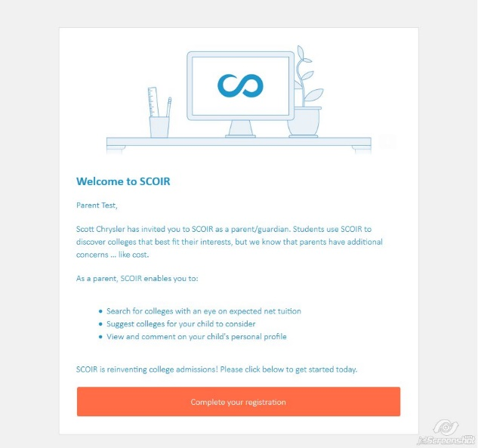
Create and confirm your password then click the Sign Up button.

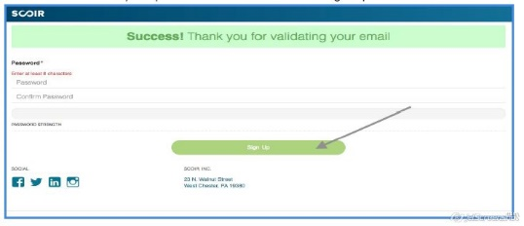

Once you have created your account, you will have full access to the powerful functionality of SCOIR. Please see the other tutorial topics to help you navigate all of SCOIR’s features.

When you initially log in to www.scoir.com, you will be greeted with the following screen:

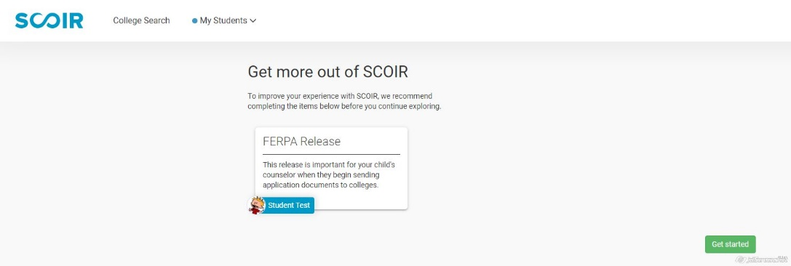

It is critically important that you complete the FERPA Release at this time. This release gives ESA permission to send the necessary documents to the colleges and universities to which your child will be applying. This release must be granted or the college counseling office will not be able to send documents to colleges. This release only needs to be completed by one parent. Once it has been completed by one parent, this screen will no longer appear.

Clicking the Get started to the lower right will bring you to the FERPA Release information.

Once you have completed the FERPA Release, you will arrive on the main SCOIR landing page.
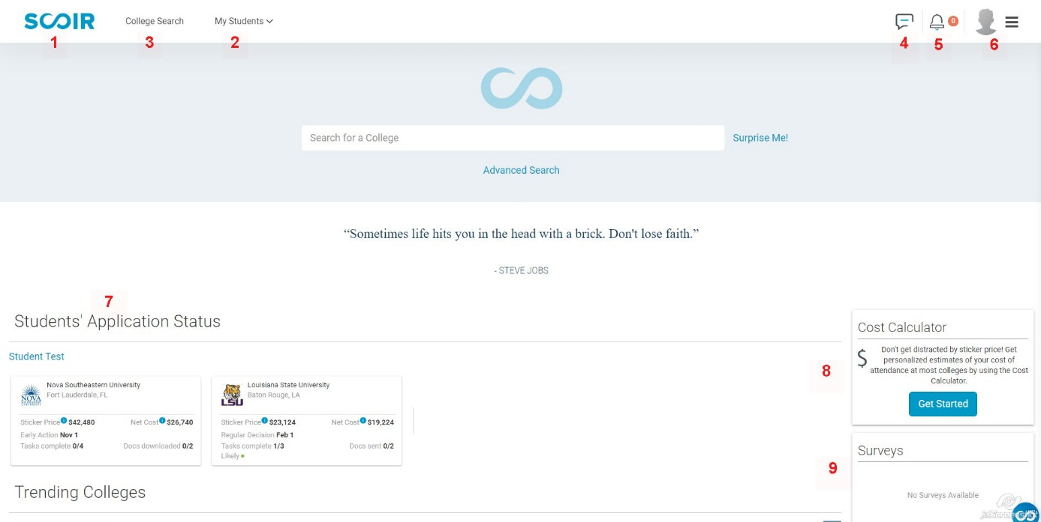

1. SCOIR home button to bring you back to this page
2. My Students – if you have multiple children at ESA, this will enable you to toggle between each student’s information using this drop down menu and selecting the child’s name you
want to see
3. College Search – Brings you to SCOIR’s college search engine
4. Message center – this is rarely used for direct messaging as we do not need one more place to keep track of information, but you will be able to keep track of important college
counseling notification here as well. You will receive these notifications via email if you
select this option via My Profile
5. Unread notification alert
6. “The Burger Button” – access to My Profile, SCOIR support, Sign Out and the like
7. Student’s Application Status – information about the schools your child is applying to, each
school tile is clickable to access more information
8. Cost Calculator – can estimate your cost as opposed to the sticker price of a college
9. Surveys – this is where you will find your Parent Questionnaire when it is released

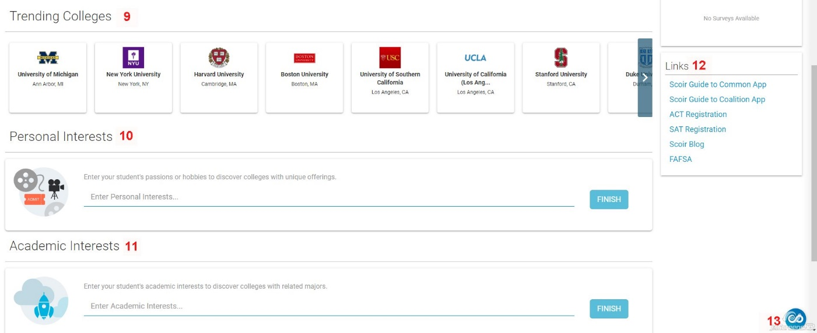

9. Trending Colleges – A feed that reflects the colleges students across the country are
accessing on SCOIR.
10. Personal interests – these are broad categories you can enter to receive SCOIR suggested
colleges
11. Academic Interests – once again, broad categories you can enter to receive SCOIR
suggested colleges
12. Links – helpful links
13. Resource Center access – to access the help Center

THE BURGER BUTTON
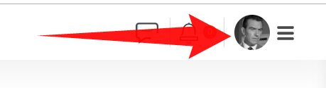
Clicking “the burger button” will give you access to many of the features on the landing page

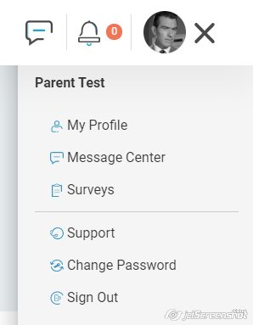

The most important is the My Profile access

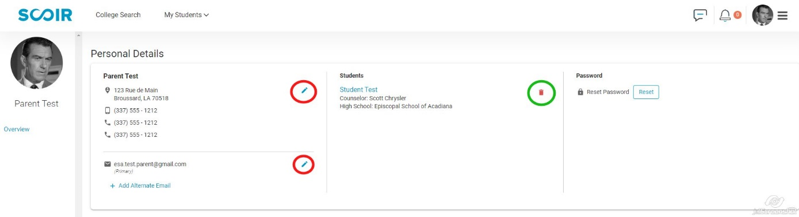

You may edit your personal information, email address, and even divorce yourself from your child in the system (you chuckle now, wait until next November).

Please be sure all of your personal information is up-to-date and correct.

IMPORTANT: Please click the pencil icon to the right of your primary email address. A dialogue box will open. Please be sure the Send me notification via email box is checked if you want to receive notification from the college counseling office by email. These notifications include approaching deadlines in the process, helpful information, and the like.

