SCOIR enables you to view your child’s Overview as well as his or her Colleges & Applications.

From the landing page, click the My Students tab and select the child you would like to view

This will bring you to the student’s landing page. You may navigate the page using the menu to the left. You may expand each heading using the icons.

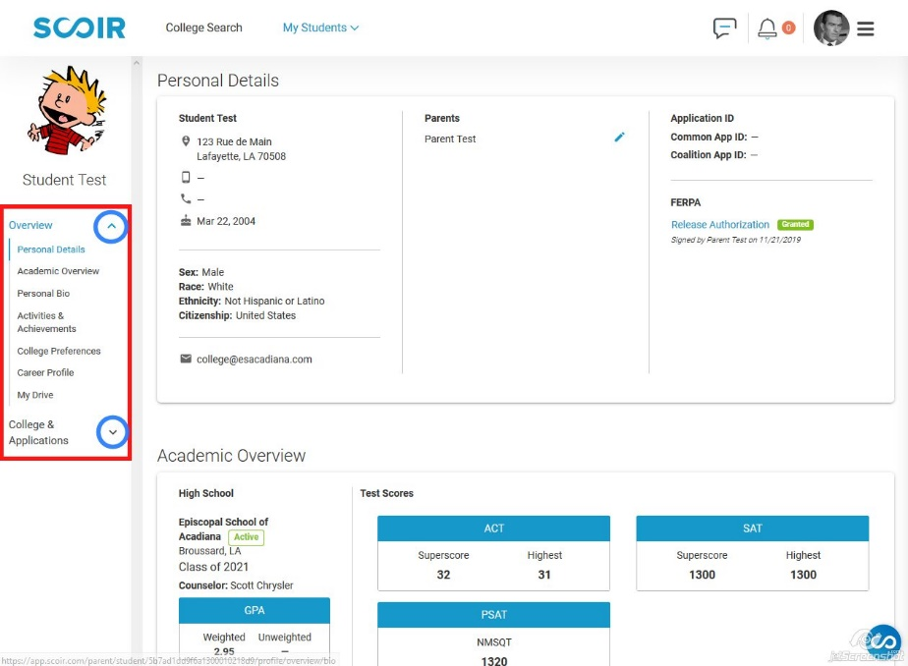

Some notes about the information you see:

The Academic Overview information is updated by the college counselor as information is available. GPA are updated for underclassmen at the conclusion of each academic year and, for seniors, at the end of each semester. Standardized test scores are updated as the college counseling office receives the scores. If your child has missing scores, please have your child see the college counselor.

Personal Bio is an optional and very brief statement you child writes about himself or herself.

Activities & Achievements are entered by the student and should include school and non-school activities. Student have been advised to enter any award won under the Clubs and Activities heading until SCOIR makes an Awards heading available. This section must be completed as part of the student’s college counseling questionnaire.

College Preferences is the information your child entered regarding his or her vision of the ideal college. This section must be completed as part of the student’s college counseling questionnaire.

Career Profile – Beginning junior year, students have the option to complete this section of their profile. It is powered by YouScience, and my personal results were scary accurate. This is designed to be a helpful piece for the student and is not required though strongly recommended. It can take several sitting to work through all of the evaluation, but it is well worth it. Though I was not impressed with the list of colleges the result produced, the career suggestions were very interesting.

My Drive is an area where documents may be shared among users – think SCOIR’s own Google drive.

