SCOIR enables you to view your child’s Colleges & Applications.

From the landing page, click the My Students tab and select the child you would like to view

Expanding the College & Applications heading on the menu will make available your child’s My Colleges screen and Scattergrams.

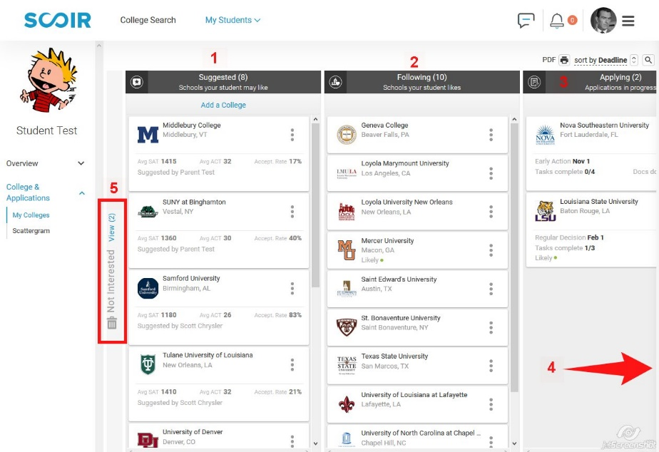

1. Suggested – Colleges your child might interested in researching as suggested by you or the college counselor. A parent may add colleges by clicking the Add a College at the top of the
column. Each tile will have who suggested the school listed.
2. Following – These are schools your child has found interesting and is currently researching in
greater depth
3. Applying – The list of schools to which your child has decided to apply and the application plan (Early decision, Early Action, Regular Decision, or Rolling) your child will use. The
application due date is also listed.
4. Applied – Once a student has submitted an application, they need to move it to the Applied
column to notify the college counselor to forward secondary school materials.
5. Not Interested – Colleges that have been suggested to your child but, for one reason or another, is no longer considering

Each tile on this screen is an active link that will take you to a fly-out screen with admission details about that school. Directly under the college’s name on the fly-out screen is a link to the college’s detailed profile in SCOIR. You can also see what documents have been sent to the college by the college counseling office and track activity for that college on this screen.

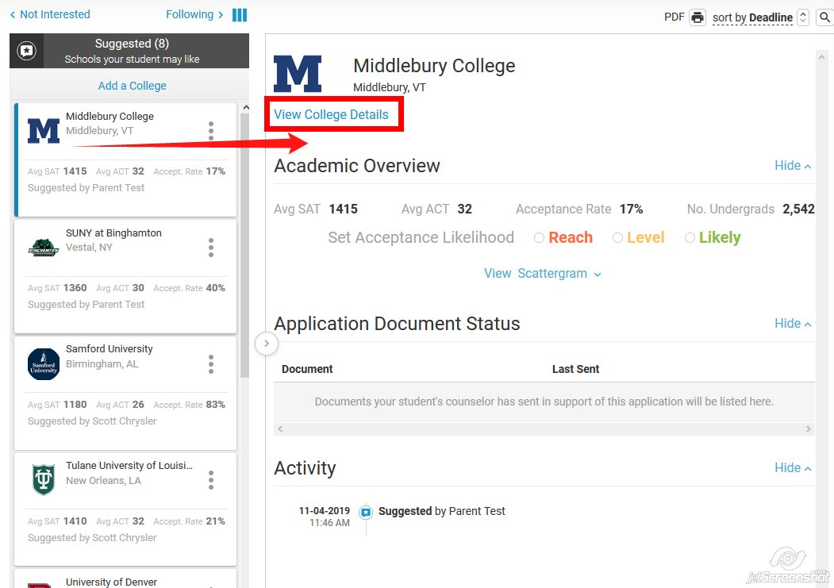

For every college that has been suggested or your child is following or applying to, you have access to a scattergram containing all of the admission decisions for ESA students since the Class of 2008 provided at least five students have applied.
You may access scattergrams directly from a college’s fly-out tile or via the Scattergram option on the menu to the left.

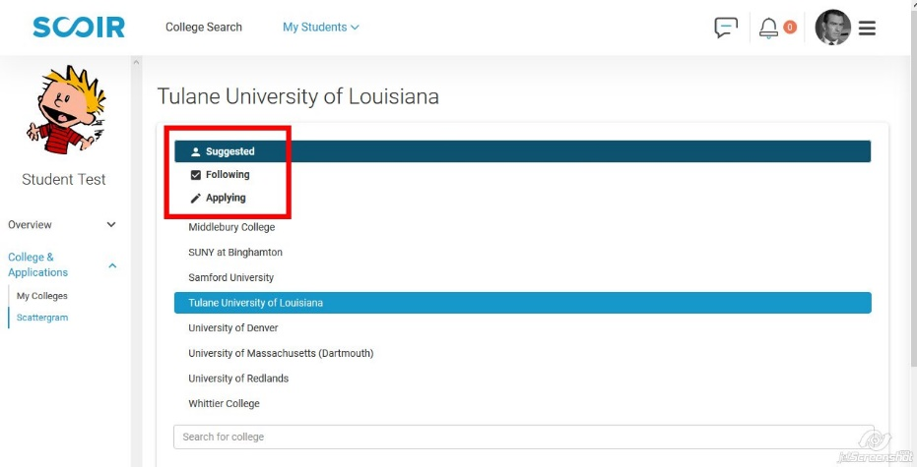

Clicking on Suggested, Following, or Applying will give you access to the scattergrams for the colleges on that particular list. Click on the college you want to view.

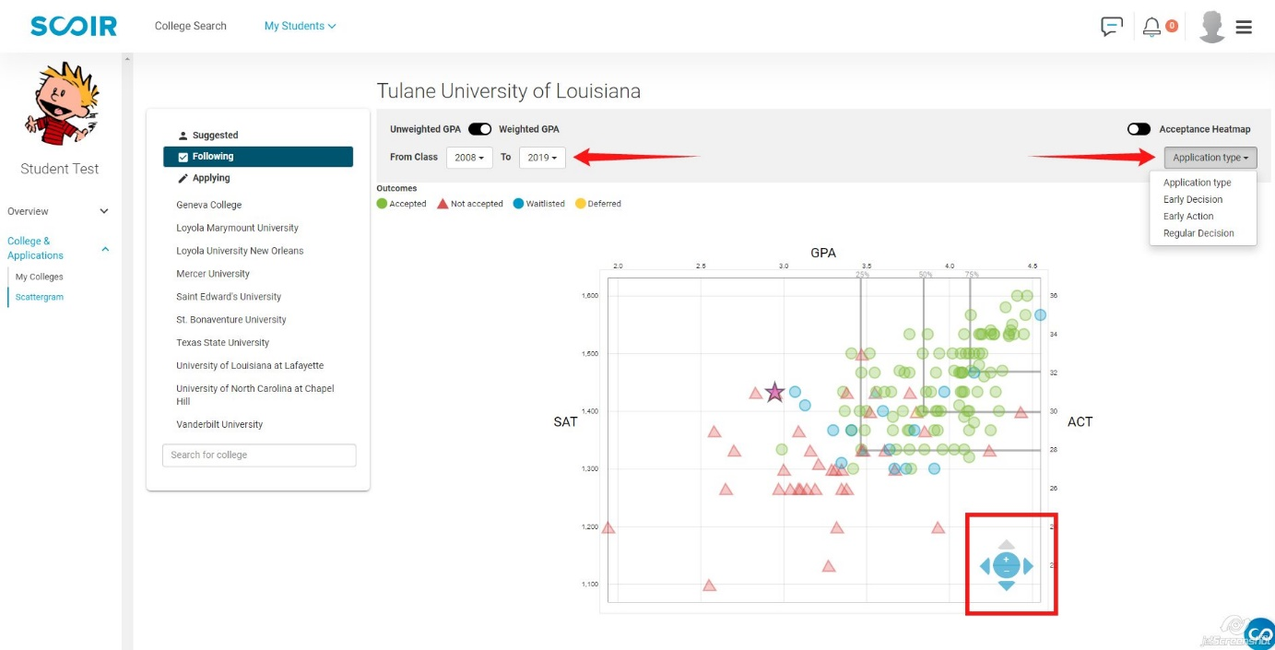

There are a few filters that may be applied to adjust the scattergram view. The first is the class range. SCOIR defaults to ESA’s entire database for each college. Once you have viewed this, it is strongly recommended that you change the range to include only the last three graduating classes so you may see current decisions. Comparing the two views will also enable you to see how the selectivity of this college has changed in the last decade.

You may also filter by application type to see how that impacts the college’s decision.

Provided your child has a GPA and at least one SAT or ACT score in SCOIR, your child will appear on the scattergram as a purple star.

You may also change the scattergram into a heatmap which overlays the acceptance percentages for areas of the scattergram.

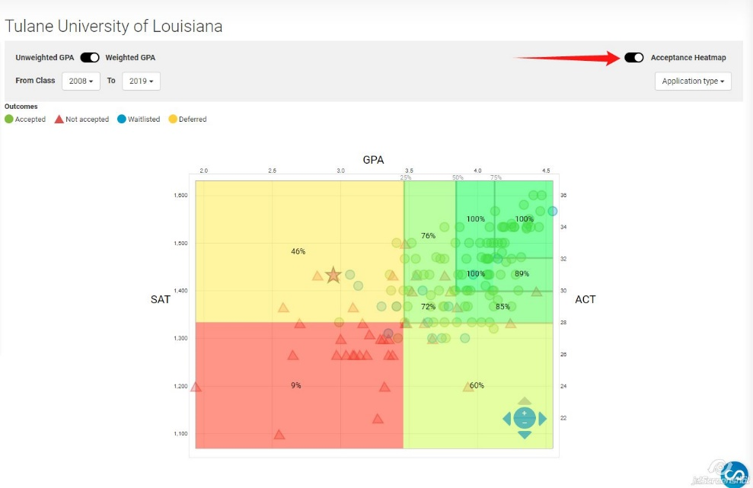

There are always exceptions to statistics, as you can clearly see on this scattergram and heatmap. However, these tools can help a family determine, using data specific to our school, the likelihood of admission to a particular school and how your child moves along the X or Y axis may impact that likelihood.

