A main source of anxiety in the college process is where to begin. There are so many choices and options. How does a student begin to find colleges that might be appropriate for him or her to consider? A major benefit of being a SCOIR school is that SCOIR makes it easy to start the search by offering both a preference and advanced search.

From the landing page, select College Search

This will take you to the main search screen which defaults the results of your child’s Preference Search – those colleges that meet the characteristics your child entered for his or her ideal school.

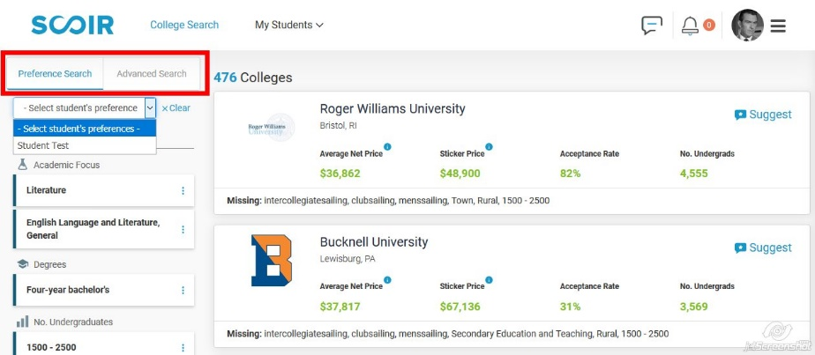

Searches may be executed using either preferences or, in the Advanced Search area, very specific criteria. It is easy to toggle between the two using the selector to the top left.

Each search permits you to clear or reset the search parameters with one click. You may recall your child’s Preference Search results by simply selecting his or her name in the drop down list at the left.

Though presented in slightly different formats, the college tiles in each search provide you with very helpful information. Each tile is also an active link to the college’s detail page – just click on the college logo.

Preference Search result tile:

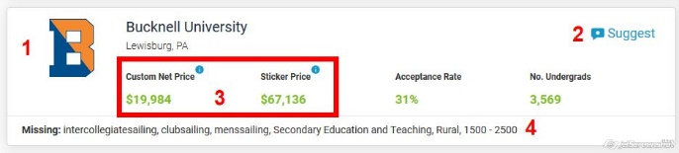

1. Click through to college detail page
2. Click to add this school to your child’s Suggested list
3. Your estimated out-of-pocket based on your responses to the Cost Calculator – see the Cost
Calculator tutorial to refine this number
4. The preferences requested that this school is missing

Advanced Search result tile:

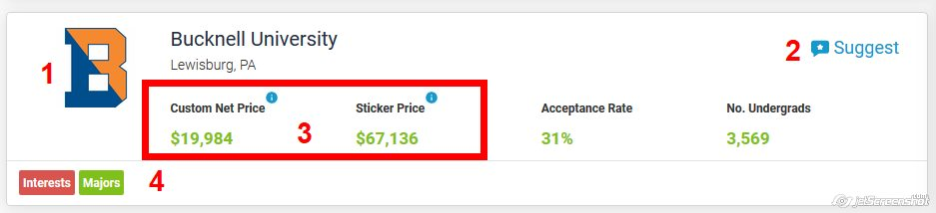

1. Click through to college detail page
2. Click to add this school to your child’s Suggested list
3. Your estimated out-of-pocket based on your responses to the Cost Calculator – see the Cost
Calculator tutorial to refine this number
4. Results are color coded – Green if the college has the criteria, Yellow if only some of the criteria, and Red if none of the criteria

