One of SCOIR’s primary objectives is to help families understand the cost of college and how the sticker price is not always what is paid.

To help families understand what a particular college may cost for them, SCOIR makes available the Cost Calculator. You do not to use this feature to make use of all of SCOIR’s other resources.

Should you choose to make use of the Calculator, the information you enter is secure and viewable only to you. The customized cost you see on search result tile is not seen by your child.

From the main landing page, click on the Get Started button in the Cost Calculator

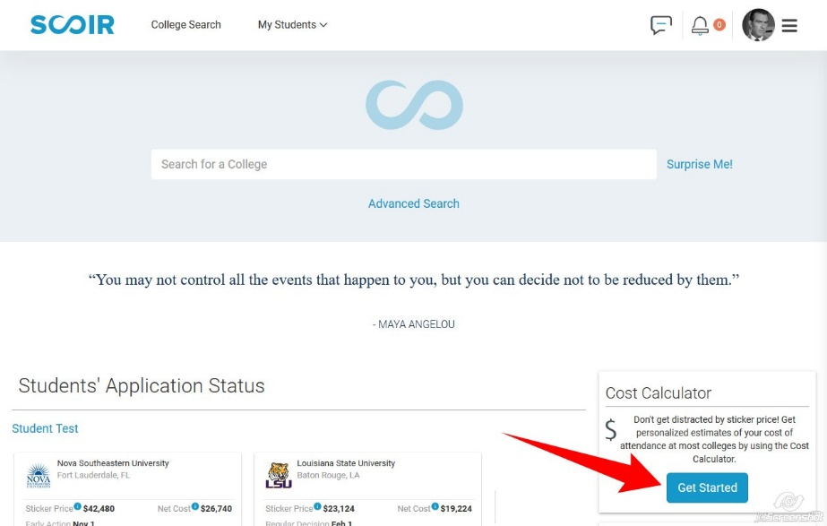

It will give you an explanation screen and information about SCOIR’s Privacy Policy, click Continue

The actual calculator will give you three options:

- Use the default net average price the college publishes
- Use an income-based net price – you select an income range from a dropdown list
- Create custom price estimate – you enter data and the calculator customizes the estimated price based on your circumstances

The Custom Price Estimate Questions

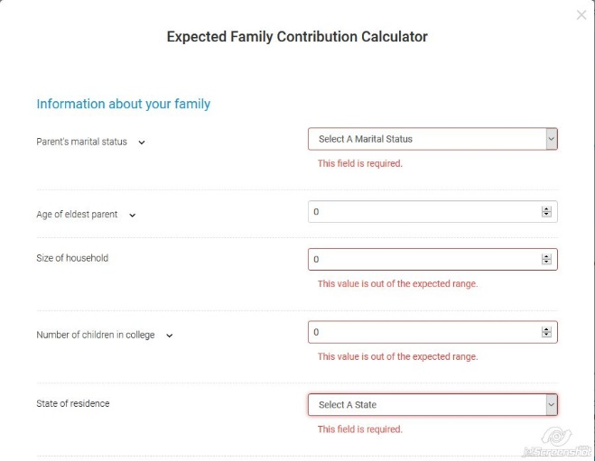
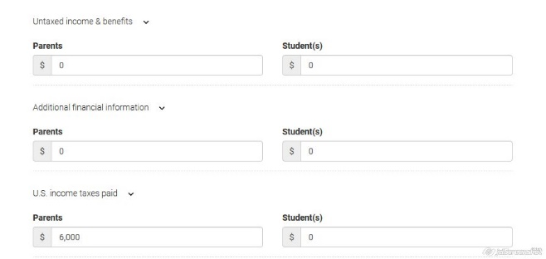

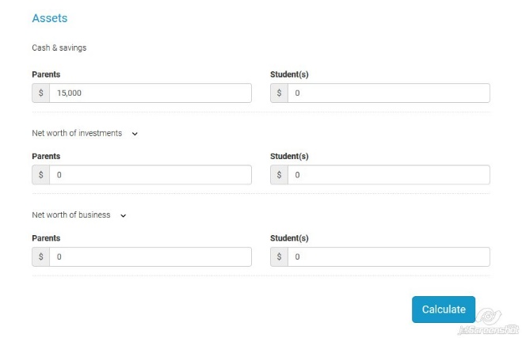

Notes: If the child has separate households, the custodial parent should be the one who completes Custom Price Estimate Questions. The custodial parent in the eyes of college financial aid is the parent with whom the child resided the most. If the custodial parent is re-married, the step-parent’s income should be included in financial report. Non-custodial parent financial information will be collected by the colleges and influence the final expected family contribution (EFC) for the student.

